1. Introduction
   * Give thought process on final look
     1. Want it to have a ‘futuristic’, expensive look
     2. Want exposed metal as to denote it is well made and isn’t fragile
     3. Upper legs to be made of rubber – can contract such as the artificial muscles in iRobot
     4. Mimic the running blades from real world – carbon fibre and plastic
     5. Some wear and tear on arms to show that it has been used, already competed
     6. Want recessed parts of torso on front and back to have mesh effect to mimic cooling venting
   * Give ideas on how I want final render to look lighting wise
     1. Want the robot to be singled out
     2. Dark surroundings, to put spotlight on main character – for movie promotion
     3. Show light reflections on robot to clearly show its metallic structure
     4. Want multiple shadows created from robot onto the court, mimicking the lighting inside a sports arena where multiple shadows are often cast on athletes
   * Final render plan
     1. Want robot to be centre frame
     2. Robot to be mid jump shot
     3. Camera looking up to robot to give heroic connotations
     4. Have badminton net in foreground, blurred
     5. See very dark surroundings of rest of arena in background
2. Challenges and Highlights
   * Badminton court, net and surroundings
   * Arms and shoulder plates
   * Hinges
   * Legs
   * Front and rear venting, piping
   * Main torso and head
   * Badminton racket
   * Lighting
   * Rendering and camera settings
3. Discussion and conclusion
   * Evaluate submission
   * What can be improved with more time
     1. Make mesh on vents match when passing from one UV shell to another
     2. Create a specularity map for court so that I could mimic high frequency areas being smoothed out by continual use
     3. Make legs more synthetic muscle like
     4. Add more detail to background
   * What would I do differently next time?
     1. Instead of repeating processes, use material node editor to link one material to multiple attribute fields
     2. Could have mapped union jack to shoulder plate easily in UV editor as outside faces were in separate shell
   * If had to do project again, know knowing pipeline, would you model geometry differently or at different resolution?
4. Appendix
   * Render progress
   * Design changes
   * Links to textures used

**Character and Set Design – Texturing, Lighting, and Rendering**

**Introduction**

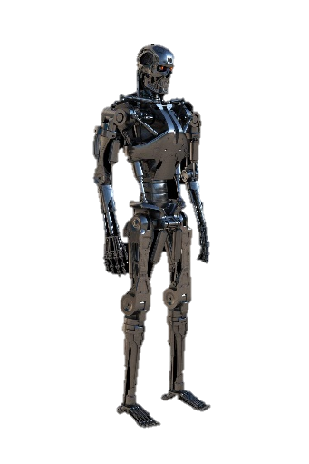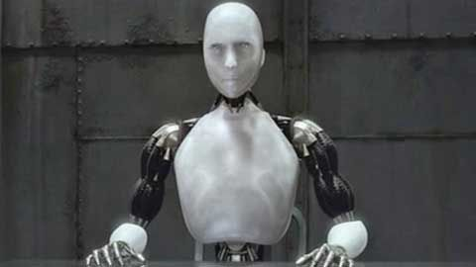When planning the final design of my Olympoid character, I decided that I wanted to portray an expensive, futuristic, yet rugged look. Inspiration for this aesthetic was a combination of the appearances of the iRobot character Sonny, and the T-800 from Terminator, as well as the thought process made as a result of the initial design brief; If a country is going to be represented by a single robot, then that country will want to show off and give a good impression to the rest of the world. Having materials such as chromed metals, metallic paint, and carbon fibre will give an expensive and futuristic look to the Olympoid. Portraying a rugged look will give off the aura that the Olympoid is able to compete in all events without worry of taking critical damage. I hoped to achieve this by having some of the chromed metal, or paint showing signs of wear through chips or scuffing.

For the lighting I wanted to have the character singled out in the scene, to draw all attention to it. I also feel that having almost a spotlight effect, and a high contrast between the character and the background, will highlight and show off the chromed and metallic sections of the Olympoid well due to the high specularity of these materials. The inspiration and motivation for a spotlight effect came from the brief, detailing that the final render is for movie promotion. I believe that a shot with this effect will create a dramatic and engaging promotional shot. With the lighting, I also wish to create multiple shadows on the flooring below the character, mimicking the lighting seen at sporting events held inside arenas and sports halls.

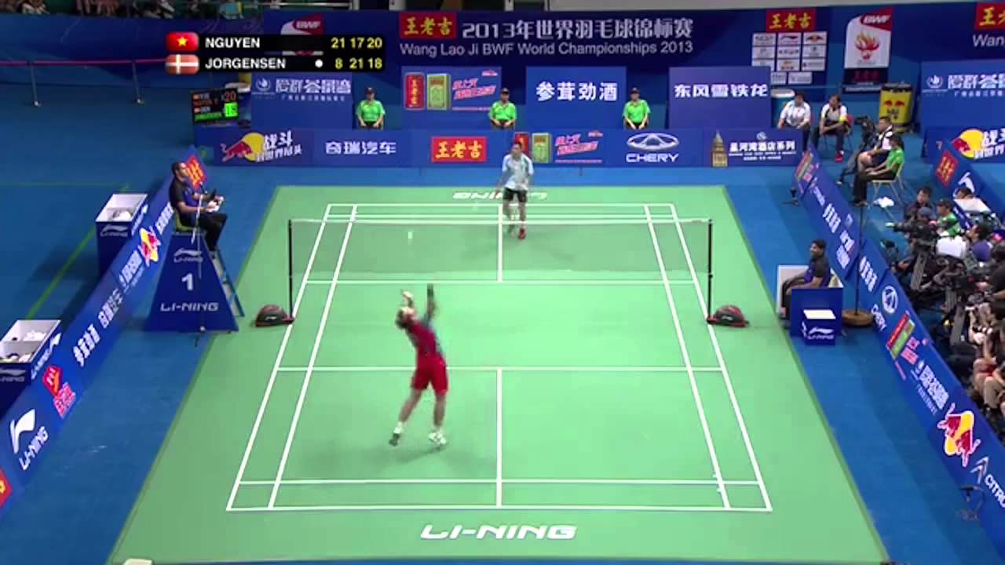Due to the lighting of the scene creating a dramatic mood for the shot, I wished to carry this into the final render. Me idea for the render was to have the robot in centre frame, carrying out a jump shot with the shuttlecock just out of frame, with the camera looking up upon to the Olympoid. As well as adding to the dramatic aesthetic, a shot portrayed in this way would show the abilities of the Olympoid, as well as giving heroic connotations to, presumably, the protagonist of the movie being promoted.  
I also wished to have foreground elements blurred to give the shot depth, rather than producing a flat image with no perceivable depth, especially as most of the scene will be very dark.

**Challenges and Highlights**

*Badminton Net, Court, Flooring*

­ Initially, I decided I wanted to model a badminton net to place in the frame. I composed a simple net structure from prefab squares for the stands, and a plane for the net, using real life Olympic nets as an example. Given that the stands in real life are painted metal, I tried to mimic this effect by increasing the metalness and roughness factors, while decreasing the specularity to about half. This meant that while there are some close reflections, the surface itself is fairly diffuse. Increasing sheen to 0.3 then gave the final desired look. I then added a 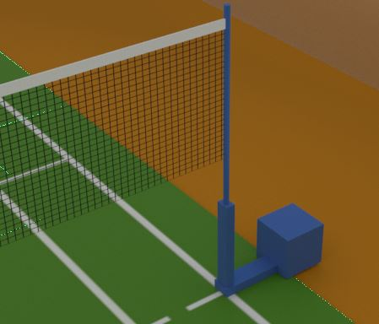blue colour to mimic real life Olympic stands.

Modelling the net on a plane needed to be done in a way so that the net was transparent between the netting threads. Initially I had planned to use the *Cloth* prefab instead of the *Grid* prefab, as I would have been able to achieve a much more realistic cloth effect mesh; interweaving threads, waved threads. Whilst this worked in the preview screen, I was still not getting a mesh effect in the render view, with transparency between grid squares. To achieve this, I looked online and found that I had to set the Transparency Algorithm to Alpha cut inside the render settings. However, due to the slight variation in colour of the cloth lines at line intersections, I was unable to get a complete mesh at render time. Through experimentation I achieved the desired effect when changing to *Grid*. Adding the *Grid* pre-set to the colour attribute of the standard shader and increasing the repetition factors to get the correct mesh density gave me the look I desired. I then applied the same *Grid* pre-set to the opacity value, adjusting the settings to exactly match those I had set in the colour attribute field.   
The top of the net was set to a white colour with specularity substantially reduced. To give it a more ‘pure white’ effect I slightly increased the emission value of the shader, which achieved the desired effect I was after.

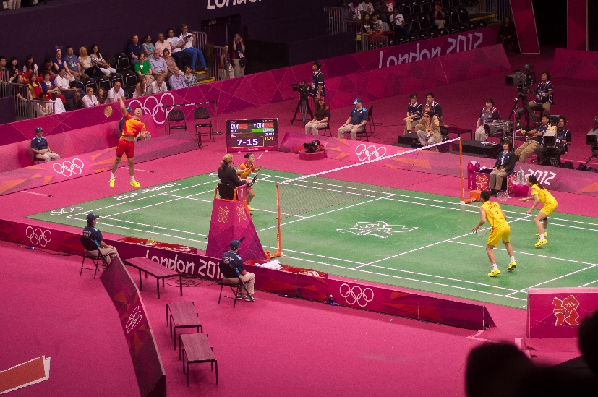After looking into Olympic badminton courts, I observed that; there were banner placards on each side of the court, the flooring surrounding the court had very low specularity often with worn, uneven colouring, and that the court itself had a rough surface, but some reflective properties.   
Creating the court was achieved by allocating an image I found online to the colour attribute, then reducing the specularity to 0.4, and increasing the roughness to 0.5 in order to achieve the desired reflective properties.   
The floor itself was modelled using a plane and attributing the desired colour to it. Again, roughness was substantially increased, and specularity the opposite. To get the desired worn effect, I changed the colour attribute to the noise pre-set. This enabled me to create patches of lighter and darker orange experimenting with the *threshold, amplitude*, *and frequency ratio*, to mimic some mild wear.   
The court-side banners were fairly diffuse but had some reflections apparent on them in pictures found online. To mimic this, I decreased specularity, increased roughness, and increased the sheen attribute of the *aiStandarShader*. This produced the desired effect of being diffuse yet showing some lighter areas due to the gloss sheen that seemed to be present on the real-life banner counter parts.

*Olympoid Arms and Shoulder Plates*

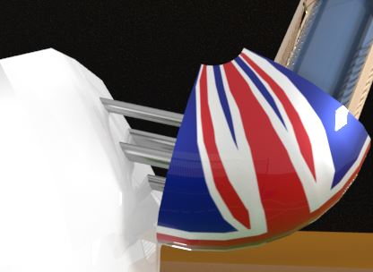To link my Olympoid back to the Olympics, I decided to make the shoulder plates show the Union Jack – showing that it was representing Great Britain. In order to allocate the union jack to the plates, I found an image online, and allocated this to the colour field with a *file* render node attached to it. Whilst I was happy with how the image was wrapped around the shoulder plate, I only wanted it to be present on the outside of the shoudler plate. Initially, I looked at the UV editor to see how the UV shells had been constructed, and thought it to have been one single shell meaning it would have proved challenging to map the image to just the selected faces. So instead, I manually selected all the outer faces of the shoulder plates geometry and assigned a new *aiStandardShader* to just these faces. This then allowed me to achieve the desired look – as though the Union Jack had just been painted on the exterior. To then achieve the metalic look I wanted, I used the *Car Paint Metalic* preset on the shader; slightly reducing the specularity, and slightly increasing the roughness. Once I had lit my scene, I achieved the high-end, painted effect I was after.  
The inside face of the shoulder plate, along with the shoulder (and leg) ball joints, was made to be a muted, dark grey as to not draw attention to them, whilst fitting into the colour and material design of the robot.   
Joining each arm to the torso are four piston rods. Moddeling off of real life pistons, I used the *Chrome* preset for the shader. The result gave me the desired look straight away, and so required no further modification.

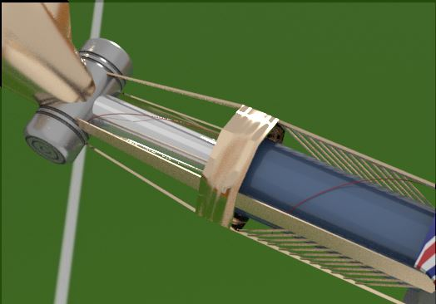The upper arm is composed of a piston, a wire, and the protective exoskeleton. Detailing the upper arm proved challenging as during the modelling phase, I had used *boolean union* to combine the piston, wire, ball joint, and connecting rods. In hindsight this was a big mistake, and made texturing the upper arm much more difficult and time consuming than it should have been.   
As a result of combining all the objects, their UV geometry was hideouse. Whilst I could have re-modelled this section of the geometry (as using separate didn’t work due to the history being deleted) I instead chose to select all faces, and then deselect the faces I didn’t want texturing, before adding a new shader to the faces I wished to tecture at that moment.  
For the wire, I simply reduced the specularity to 0 on the *aiStandardShader*, and then assigned the colour red. The only challenge faced here was selecting the faces as described above.  
For the piston, I used two shaders; one for the piston arm, one for the piston housing. As with the connecting rods, the piston arm was assigned the *Chrome* preset as this gave me the look I wanted, perfectly mimicing a real life piston arm. For the housing, I used the *Car Paint Metalic* preset once again, but this time only slightly reducing specularity to 0.8.   
I had attempted to create a cracked paint effect on the piston housing, to give a weathered effect. I found an appropriate image online, and tried to create a specularity map in order to have areas of different specularity on the shader. However, once applied I didn’t feel as though this fit with my design plan, and so instead went with the polished, painted appearance that was described above.

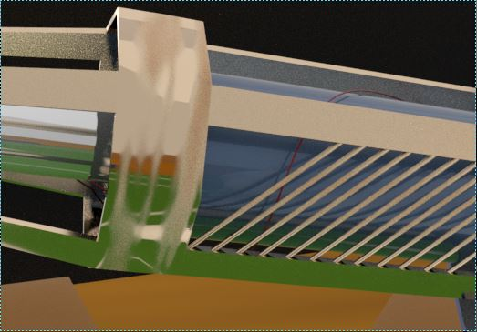One of the more challenging, but rewarding, sections of the texturing process was that of the protectve exoskeleton. I wanted to have this piece to have a worn and slightly battered appearance, whilst looking metalic – for rigidity and toughness. I played around with the presets available for the *aiStandardShader*, and after some experimentation decided on the *Copper* preset. This material preset gave me a metalic, high-end looking material which fit in perfectly with the current materials, and my design plan. Once I had decided on this I set about adding in wear and tear effects. To accomplish this I created a black and white specularity map in Gimp 2.0. Applying this map to the specularity field of the exoskeleton’s shader gave the desired affect. After playing around with the map, controlling how much wear I wanted and where I wanted it to appear, I settled on what is presently on the model.

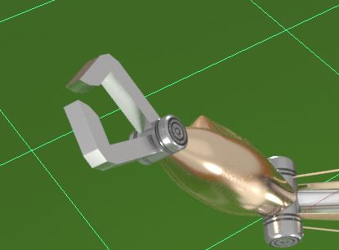To adhear to continuity, the forearm was assigned the *Copper* preset also, however the metalness was decreased slightly, and the roughness increased slighlty to give a more worn effect. The claw shader was assigned the *Brushed Metal* preset, with the colour slightly darkened as to what is given in the preset. Combining these with the rest of the arm gave a cohearent and attractive look to the arm as a whole, whilst giving off a high-end, robotic, rugged impression, and is the part of the model I am happiest with – both looks wise, and due to the challenges over come in order to achieve the finished look.

*Limb Hinges*

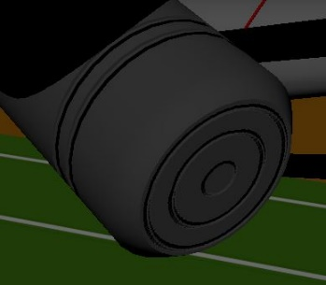Found at the elbow, wrist, and knee joint positions on the Olympoid are cylindrical joints. At the time of modelling, the decision was made to leave them blank and add appropriate detail during the texturing stage of the pipeline. Due to the rest of the arm being comprised of metal, I chose to stick with this theme to give a cohesive aesthetic. Subsequently, I assigned the *Brushed Metal* material to the *aiStandardShader* assigned to the hinge.   
To create the detail seen on the hinge, I took a copy of the UV map setup and, in Adobe Photoshop, created a bump map (see Appendix) with balck in the areas I wished to be recessed. This bump map was then applied to the *Bump Mapping* field in the *Geometry* tab in the shader. This gave the desired effect perfectly, and adds subtle but appropriate detailing to the hinge.  
One challenge I did face was with the bump map creation. After creating the initial mapping, the geometry didn’t change despite black areas being present. After some trial and error I found that this was because I didn’t have a white background behind the black sections, and so the map wasn’t being applied correctly. After fixing this issue, the bump map worked perfectly.

*Legs and Running Blades*

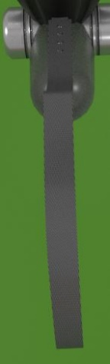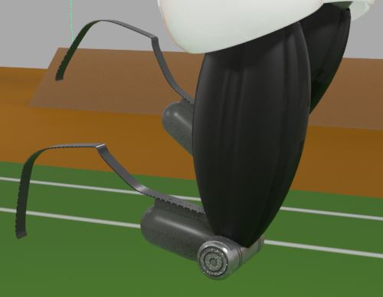Inspiration for the thighs of the Olympoid was taken from iRobot from the beginning of the modelling process. Seen on the robot Sonny, there are many synthetic muscles made from a rubber type material. In order to try and replicate this aesthetic, I added some indentation lines into the light geometry in order to give the object depth once modelled. Whilst the effect I achieved is fitting with the character, and the effect I was going for, I did also try to map a texture onto the thigh shader, although it did not result in the right look. I have used the *Rubber* preset, and set the colour to black, with the result looking as though it is capable of contracting.

For the lower half of the leg, I had modelled tis off of a Para-Olympian’s prosthetic leg, that would be found at today’s Para-Olympics. Due to this, when it came to texturing, I also wished to mimic the likeness of current day prosthetics. The upper portion uses the *Plastic* preset in order to convey the appearance of fibreglass or plastic, whilst the blade section of the model has had its specularity increased to give a some what reflective appearance, as well as having an image of carbon fibre material attached to the colour attribute. Initially when the carbon fibre texture was applied, the image was stretched and so the effect of carbon fibre was distorted. To combat this, I set the image to be repeated 4 times in the U direction; resulting in the close knitted effect that carbon fibre has.

*Front and Rear Venting*

S

*Torso and Head*

K

*Badminton Racket*

O

*Lighting*

L

*Positioning and Rendering*

H

**Discussion and Conclusion**

Ok